Grace Lutheran Church
239 E North St
Hastings MI 49058

Website: www.grace-hastings.org
Facebook: Grace Lutheran Church-ELCA Hastings, MI
Worship Committee e-mail: gracelutheranworshipcommittee@gmail.com

Phone: (269) 945-9414
(269) 945-2645

Pastor Ken Scheck II
Ms. Cindy Olson, Minister of Music
July 7, 2019

The Kingdom Comes
A man experiencing homelessness enters the church on Sunday morning, and the pastor greets him. As though to provide some sort of evidence that he deserves to be there, the man reaches into his wallet and hands her a yellowed, worn-out-from-folding piece of paper. The pastor’s eyes move from the man to the paper, and she reads, “Certificate of Perfect Sunday School Attendance at First Lutheran Church.” It is his most prized possession, carried through every crisis on a difficult journey.
Decades before, Sunday school teachers in the classrooms of First Lutheran Church had loved and served a little boy. Planning lessons on Saturday evenings, teaching him stories and songs about God’s love each Sunday morning, they planted in him a sense of belonging, of being beloved by God. The kingdom work they started in that little boy still stirs in him as he crosses the threshold of a church and reaches into his wallet, handing his certificate to the pastor.
When Jesus sends the seventy out to proclaim the good news of God in every town, he makes it clear that whether they are welcomed or rejected, they are to say plainly that “the kingdom of God has come near” (Luke 10:9). As we move about our lives, we are called to love and serve where we are, trusting that when we leave, the Spirit remains.
The work of the Spirit is not finished when we leave a place. The in-breaking of the kingdom does not depend on our remaining or being present to continue the work. God will keep breathing life into people long after we have moved on, maybe even years after Sunday school teachers have awarded stars and certificates. The love we offer and the stories and songs we teach are just some of the ways we declare that the kingdom of God has come near. The Spirit moves, and we get to participate!

From sundaysandseasons.com.
Copyright © 2019 Augsburg Fortress. All rights reserved.
BEFORE WORSHIP
Please fill out our Participation Card and place it in the offering plate every Sunday. This card helps the ministry of both the Congregational Care and Community Outreach Committees. Sometimes there are additional questions on the back of the card, so don’t forget to check both sides of the card.

Fourth Sunday After Pentecost
July 7, 2019

Pentecost is a season for growing represented by the color green. We celebrate the founding of the church and the fruits of the Spirit.

Holy Silence is observed as we enter to worship.

Welcome/Worship Instructions
Arise in body or spirit

Greeting
The pastor and the assembly greet each other.

P The steadfast love of God, the life of Jesus Christ, and the growth of
the Holy Spirit be with you all.
C And also with you.

A O Lord, open our lips,
C and our mouths shall proclaim your praise.

P Blessed God, satisfy us in the morning with your steadfast love,
C that we may rejoice and be glad all our days.

A Give praise to the Holy Trinity our true God,
C who gives us life, salvation and resurrection.

Gathering Music Great is Thy Faithfulness ELW 733 (red book)

Prayer of the Day
A Let us Pray… O God, the Father of our Lord Jesus, you are the city that shelters us, the mother who comforts us.
C With your Spirit accompany us on our life’s journey, that we may spread your peace in all the world, through your Son, Jesus Christ, our Savior and Lord. Amen.

Sit

First Reading Isaiah 66:10-14
Those who returned from the exile found that the hopes for the glorious restoration of Judah were not completely fulfilled. For these disappointed people, the prophet envisions salvation in the image of a nursing woman. Mother Jerusalem and a mothering God remind the community how they are sustained and supported.

L A reading from Isaiah:
¹⁰Rejoice with Jerusalem, and be glad for her, all you who love her; rejoice with her in joy, you who mourn over her—¹¹that you may nurse and be satisfied from her consoling breast; that you may drink deeply with delight from her glorious bosom. ¹²For thus says the Lord: I will extend prosperity to her like a river, and the wealth of the nations like an overflowing stream; and you shall nurse and be carried on her arm and dangled on her knees. ¹³As a mother comforts her child, so I will comfort you; you shall be comforted in Jerusalem. ¹⁴You shall see, and your heart shall rejoice; your bodies shall flourish like the grass; and it shall be known that the hand of the Lord is with his servants, and his indignation is against his enemies.
L The word of the Lord.
C Thanks be to God.

Psalm 66:1-9
¹Be joyful in God, | all you lands;
be joyful, | all the earth.
²Sing the glory | of God’s name;
sing the glory | of God’s praise.
³Say to God, “How awesome | are your deeds!
Because of your great strength your enemies | cringe before you.
⁴All the earth bows | down before you,
sings to you, sings | out your name.” R
⁵Come now and see the | works of God,
how awesome are God’s deeds | toward all people.
⁶God turned the sea into dry land, so that they went through the wa- | ter on foot,
and there we re- | joiced in God.
⁷Ruling forever in might, God keeps watch o- | ver the nations;
let no rebels ex- | alt themselves.
⁸Bless our | God, you peoples;
let the sound of | praise be heard.
⁹Our God has kept us a- | mong the living
and has not allowed our | feet to slip R

Second Reading Galatians 6:1-6, 7-16
In the close of his letter to the Galatians, Paul encourages them to live as people made right with God through faith in Jesus Christ. Here Paul offers practical advice about how believers exercise common concern for one other in “the family of faith.”

L A reading from Galatians:
^{[1}My friends, if anyone is detected in a transgression, you who have received the Spirit should restore such a one in a spirit of gentleness. Take care that you yourselves are not tempted. ²Bear one another’s burdens, and in this way, you will fulfill the law of Christ. ³For if those who are nothing think they are something, they deceive themselves. ⁴All must test their own work; then that work, rather than their neighbor’s work, will become a cause for pride. ⁵For all must carry their own loads.
⁶Those who are taught the word must share in all good things with their teacher.]
⁷Do not be deceived; God is not mocked, for you reap whatever you sow. ⁸If you sow to your own flesh, you will reap corruption from the flesh; but if you sow to the Spirit, you will reap eternal life from the Spirit. ⁹So let us not grow weary in doing what is right, for we will reap at harvest time, if we do not give up. ¹⁰So then, whenever we have an opportunity, let us work for the good of all, and especially for those of the family of faith.
¹¹See what large letters I make when I am writing in my own hand! ¹²It is those who want to make a good showing in the flesh that try to compel you to be circumcised—only that they may not be persecuted for the cross of Christ. ¹³Even the circumcised do not themselves obey the law, but they want you to be circumcised so that they may boast about your flesh. ¹⁴May I never boast of anything except the cross of our Lord Jesus Christ, by which the world has been crucified to me, and I to the world. ¹⁵For neither circumcision nor uncircumcision is anything; but a new creation is everything! ¹⁶As for those who will follow this rule—peace be upon them, and mercy, and upon the Israel of God.
L The word of the Lord.
C Thanks be to God.

Gospel Acclamation We Eat the Bread of Teaching ELW 518
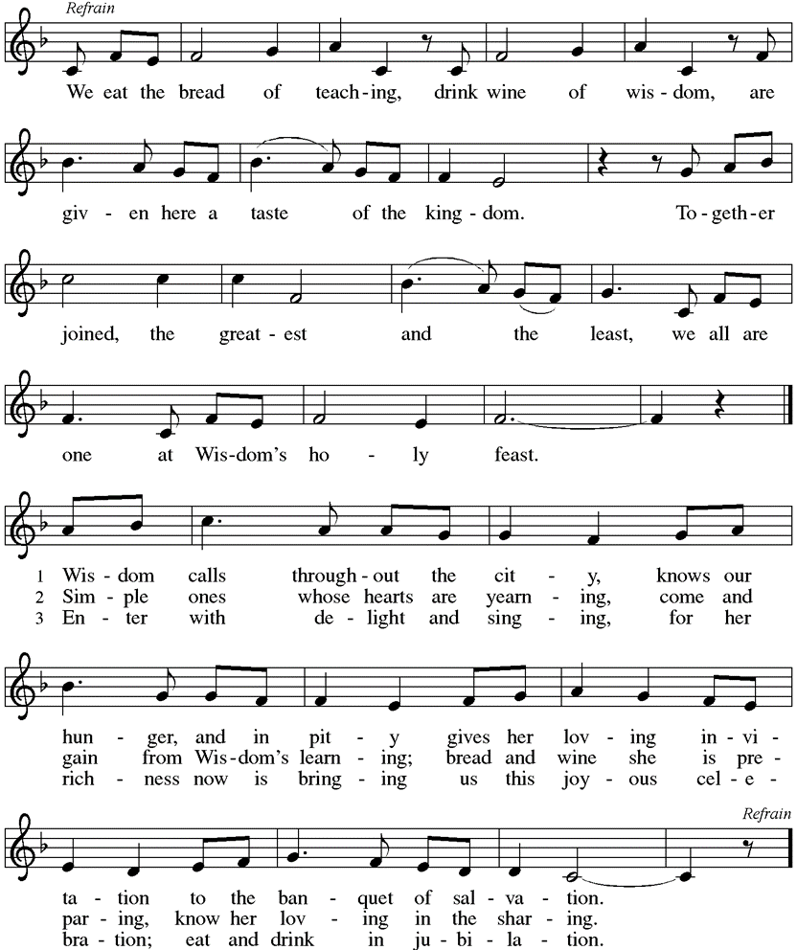
All stanzas

Gospel Reading Luke 10:1-11, 16-20
Jesus commissions harvesters and laborers to go where he would go and do what he would do. Risking hardship and danger in exchange for the experience of great joy, they offer peace and healing as signs that the reign of God is near.

P The Holy Gospel, according to Luke.
C Glory to you, O Lord.
¹After this the Lord appointed seventy others and sent them on ahead of him in pairs to every town and place where he himself intended to go. ²He said to them, “The harvest is plentiful, but the laborers are few; therefore, ask the Lord of the harvest to send out laborers into his harvest. ³Go on your way. See, I am sending you out like lambs into the midst of wolves. ⁴Carry no purse, no bag, no sandals; and greet no one on the road. ⁵Whatever house you enter, first say, ‘Peace to this house!’ ⁶And if anyone is there who shares in peace, your peace will rest on that person; but if not, it will return to you. ⁷Remain in the same house, eating and drinking whatever they provide, for the laborer deserves to be paid. Do not move about from house to house. ⁸Whenever you enter a town and its people welcome you, eat what is set before you; ⁹cure the sick who are there, and say to them, ‘The kingdom of God has come near to you.’ ¹⁰But whenever you enter a town and they do not welcome you, go out into its streets and say, ¹¹‘Even the dust of your town that clings to our feet, we wipe off in protest against you. Yet know this: the kingdom of God has come near.’ ”
¹⁶“Whoever listens to you listens to me, and whoever rejects you rejects me, and whoever rejects me rejects the one who sent me.”
¹⁷The seventy returned with joy, saying, “Lord, in your name even the demons submit to us!” ¹⁸He said to them, “I watched Satan fall from heaven like a flash of lightning. ¹⁹See, I have given you authority to tread on snakes and scorpions, and over all the power of the enemy; and nothing will hurt you. ²⁰Nevertheless, do not rejoice at this, that the spirits submit to you, but rejoice that your names are written in heaven.”
P The Gospel of the Lord.
C Praise to you, O Christ.
Sit

Children’s Time
All children [including infants] and youth who desire to come forward for the children’s sermon are welcomed and encouraged to do so. Parents/caregivers are welcome to accompany their child during the children’s message. There may be a time of dance and celebration that is offered.

Message
Silence for reflection

Arise in body or spirit

Song of the Day Here I Am, Lord ELW 574

Kneel or sit as able.

Prayer
A Joining our voices with God’s people around the world, let us offer our prayers for those in need.

A brief silence.

A For the church and its ministries; for pastors and musicians; for teachers and leaders, that their joyful noise clearly announce your reign of peace come near. Guide the faith of our bishops and congregations and all the servants of your church, including Bishops Elizabeth and Craig, Assistants Chrysanne, David and Roseanne; our synod companion churches Peace Lutheran, Gaylord and Grace Brethren Bible Church, Hastings; Minister of Music Cindy and Pastor Ken. Gracious God,
C We give you our praise.

A For your works revealed in creation: for rivers and streams; for thunderstorms and sunshine; and for those preparing for harvesttime, that you inspire our care for the earth. Gracious God,
C We give you our praise.

A For peace and justice in the world; for all levels of government; for areas affected by strife, that those in authority always work for the good of all, bringing your justice to all people. Protect the lives of those who serve in the military, including Zack Green (Mikolajczyks), Parker Stancil (Freedlunds), Cody and Myrina Crawford (Clements), Alexis and Dylan Kelmer, Austin and Aaron Endsley (Burdicks), Brady Rudesill (Hansen), Joel Taggart (Varkulas), and Kayla and Lance Champaco (Pohls). Gracious God,
C We give you our praise.

A For the sick and those who console them; for prisoners and those who show them mercy; for the downtrodden and those who help them flourish; for those suffering from malaria and zika; and for all in need of care, that you comfort them as a mother comforts her child, including Assisting Minister will announce names in service. Gracious God,
C We give you our praise.

A For those spending time with friends and family this summer; for those making employment decisions; for those uncertain what the future holds, that they set their minds on Christ who has called us to himself. Gracious God,
C We give you our praise.

A Be attentive, gracious God, to the individual petitions we lift to you in loud voice or in the silence of our hearts.

Here other intercessions may be offered.

A In thanksgiving for the faithful departed who have inspired us by their witness to the gospel, that with them we will know the confidence of being held in your embrace. Gracious God,
C We give you our praise.

P Merciful God, you hear the prayers of your people even before they are spoken. We commend these and all our prayers to you, trusting in your abundant mercy; through Jesus Christ, our Savior and Lord.
C Amen.

Sit

Offering of Gifts and Music
Everyone at worship is encouraged to fill it out and place a Participation Card in the offering plate every
Sunday morning.

Arise in body or spirit

Offertory Take My Life That I May Be ELW 583

Offering Prayer
A Let us pray . . . Blessed are you, O God, for the greening earth given for all, for the talents we are given to share, and for this bread and wine.
C Transform us to be the body of Christ, that, feasting on this food and drink, our lives may reflect your generosity; through Christ our Lord. Amen

Sharing the Peace of God

P The peace of Christ be with you.
C And also with you.
(We share the peace of Christ with one another.)

Great Thanksgiving

P The Lord be with you.
C And also with you.

P Lift up your hearts.
C We lift them to the Lord.

P Let us give thanks to the Lord our God.
C It is right to give our thanks and praise.

P It is indeed right, our duty and our joy, that we should at all times and in all places
give thanks and praise to you, almighty and merciful God, through our Savior Jesus Christ, who on this day overcame death and the grave, and by the glorious resurrection opened to us the way of everlasting life. And so, with all the choirs of angels, with the church on earth and the hosts of heaven, we praise your name and join their unending hymn:

You Are Holy
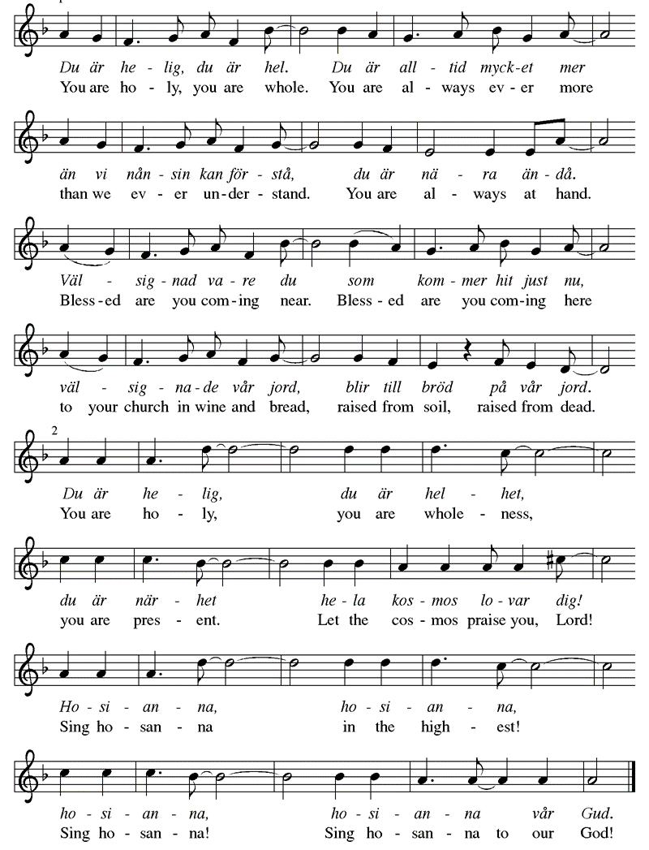

Table Prayer

P Holy God, our Maker, Redeemer, and Healer.
C in the harmonious world of your creation, the plants and animals, the seas and stars were whole and well in your praise.

P When sin had scarred the world.
C you sent your Son to heal our ills and to form us again into one.

P In the night in which he was betrayed,
our Lord Jesus took bread, and gave thanks;
broke it, and gave it to his disciples, saying:
Take and eat; this is my body, given for you.
Do this for the remembrance of me.

Again, after supper, he took the cup, gave thanks,
and gave it for all to drink, saying:
This cup is the new covenant in my blood,
shed for you and for all people for the forgiveness of sin.
Do this for the remembrance of me.

Remembering, therefore, his acts of healing, his body given up, and his victory over death.
C We await that day when all the peoples of the earth will come to the river to enjoy the tree of life.

P Send your Spirit upon us and this meal:
C As grains scattered on the hillside become one bread, so let your Church be gathered from the ends of the earth, that all may be fed with the Bread of life, your Son.

P Through Christ all glory and honor is yours, Holy God, with the Holy Spirit, in your holy Church, both now and forever.
C Amen

Lord’s Prayer
P Gathered by the Holy Spirit, let us pray as Jesus taught:
C Our Father in heaven, holy be your name. Your kingdom come, your will be done on earth as in heaven. Give us today our daily bread. Forgive us our sins as we forgive those who sin against us. Save us from the time of trial and deliver us from evil. For the kingdom, the power, and the glory are yours now and forever. Amen.

Invitation to Communion
P God invites you to this table of bounty. Come, the banquet is ready.
C Thanks be to God.

Communion at Grace
All who are present are invited to receive Holy Communion. This sacrament is a gift to all who come with open hands and open hearts to the presence of Jesus.
 Bread is served by the Pastor. Wine is served from a common cup by the Assisting Minister.
If you need gluten free bread, please let the Pastor know when you come forward.
If you prefer wine from the pouring chalice in an individual cup, take an empty cup from the tray and have it filled by the Worship Assistant. Return the individual chalice/cup to the basket provided.
 Grape Juice is provided in the pre-filled cups in the center of the serving tray.
 A Verbal Blessing may be given by the Pastor, if you do not wish to commune.
 If you wish communion brought to you in the pew, please notify the usher.

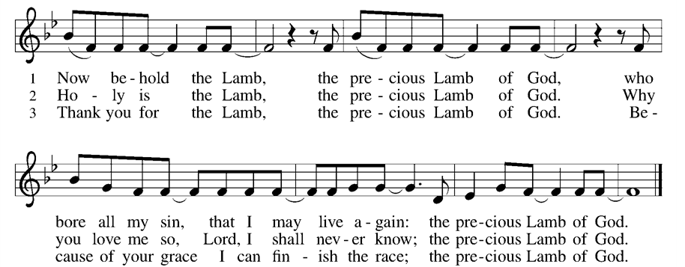
Now Behold the Lamb

Now the Silence ELW 460
Draw Us in the Spirit’s Tether ELW 470
I Come with Joy ELW 482

Sending of Communion
A Gracious God, as you raised Jesus from the dead, you give new life through bread and wine: As you sent the angel to feed Elijah with heavenly bread, assist those who set forth to share your word and sacrament with those who are homebound. In your love and care, nourish and strengthen those who will receive this sacrament, and give us all the comfort of your abiding presence through the body and blood of your Son, Jesus Christ, our Lord.
C Amen.

Prayer after Communion
A Let us pray . . . Living God, you have greeted us in our brokenness and nourished us with the body of Christ, broken for us.
C Risen to new life with you, send us now to bear your healing love into the wounded world, in the name of our risen Savior and Lord. Amen.

Mission Minutes

Arise in body or spirit.

Blessing
P Live your lives in Christ, rooted and built up in God, and abound in thanksgiving. The blessing of the holy Trinity, ☩ one God, be upon you and remain with you forever.
C Amen.

Sending Song Shine, Jesus, Shine ELW 671

Dismissal
A Go in peace. Christ is sending you.
C Thanks be to God.

Week at a Glance

Sunday, July 7 Services at 8:00 am & 10:45 am
Executive Meeting 9:30 am
Monday – Friday Vacation Bible School 5:30 – 8 pm

Saturday, July 13 BOG Highway cleanup Meet at church 8 am.

Today’s Worship Leaders
8:00 am 10:45 am
Assisting Minister Randy Teegardin Vickey Argo
Cantor Pastor Ken Mark Anton
Lector Carol Vos Sandy Mosteller
Communion Server Brenda Teegardin Laura Scheck
Acolyte/Crucifer Volunteer Mark Anton
Usher Tom & Cheryl Drumm Joe Longcor & Gwen Hansen
Greeter/Coffee Hr. Tom & Cheryl Drumm Eve Wright & Jeanette Markwart

Table Guild – Chris Bush
Bread Maker – Cindy Olson

Next Sunday’s Worship Leaders, July 14, 2019
8:00 am 10:45 am
Assisting Minister Emma Peck Traci Wales
Cantor Jack Vos Kate Watson
Lector Hope Peck Jeanette Markwart
Communion Server Jan Schreiner Diane Neeb
Acolyte/Crucifer Volunteer Lexie Watson
Usher John Burdick & Kay Marsh Doug & Diane Neeb
Greeter/Coffee Hr. Jack & Carol Vos John & Mary Kleinbrink

Table Guild – Chris Bush
Bread Maker – Cindy Olson

Stewardship Information
Worshippers last week: 130 Weekly Giving: $ 2,442.00 Budget Amount: $4,576.53

Mutual Ministry: If there is a ministry concern, please contact Kristi Winick. Kristi is our member of the Mutual Ministry Committee that is highlighted this week and can be reached by a phone call or a text message at 269-953-6638.

Vacation Bible School thanks Anna Scheck for stepping forward to be our primary decorator. We have Carol Morgan and Angela Pruitt who are helping Anna with decorations today after second service. If you would like to help them decorate, please feel free to show up.

A BIG Thank You
We thank Joe Longcor and Emma Peck for stepping up to be our leaders for Games, Kim Domke for teaching Kids Vids, and Laura Scheck and Erin Everly for doing the Crafts. We are thankful to all who are on the kitchen team by either providing food or serving: Vickey Argo, Cheryl & Tom Drumm, Bill & Lorraine Freedlund, Shayna Gibbons, Gwen Hansen, Virginia Henion, Sandy Mosteller, Amy & Phil Poholski, Laura Scheck, and Deborah Wilke. Thanks to Chris Bush and Kate Watson for helping with registration. We thank Kim Markwart, Corrina Palmer, Anna Scheck, and Connor Wales for being crew leaders. THANKS FOR THE GREAT RESPONSE THAT WE HAVE HAD IN HELPING GRACE LUTHERAN CHURCH MIINISTER TO YOUNG PEOPLE.

Brothers of Grace: The next “Adopt-a-Highway” outing is on Saturday, July 13th. Please mark this on your calendar and meet at the church at 8:00 a.m.!

Noisy Offering will be collected next Sunday, July 14th.

Executive Mtg Changed: Please meet between services today.

Annual Meeting of the Congregation will be held on July 21st at 9:30 a.m. between services. Plan to be here!

5th Annual Car Show / Outdoor Worship / BBQ: Mark your calendars for this one! On July 28th the car show will open at 9 a.m. for registration of vehicles, we will worship together under the tent at 10 a.m. on the front lawn, and lunch will be served from 11:30 a.m. – 1:30 p.m. in the Fellowship Hall.

If there is a pastoral emergency, please do not hesitate to call Pastor Ken Scheck at 269-370-4632.

